**ST. XAVIER’S COLLEGE**

**(Affiliated to Tribhuvan University)**

Maitighar, Kathmandu



**Database Management System**

**Lab Assignment #3**

**Submitted by:**

Divya Jyoti Pokharel

013BSCCSIT019

**Submitted to:**

|  |  |
| --- | --- |
| Er. Sanjay Kumar Yadav  Lecturer, St. Xavier’s College |  |

**Date of Submission:** August 3, 2015

**Additional Advantages of database approach**

* Expandability / flexibility:
* Reduces application development time
* Economy of scale
* Centralized control of DBA

**Database system components**

* Data:
* Hardware
* Software
* Users

**The data communication manager**

Database system utilizes

**Classification of DBMS**

Based on data model

Based on the number of users

Based on the ways database is distributed

**Variation of distributed environment**

**Database system lifecycle**

The database life cycle (DBLC) defines the stages involved in getting any type of database off the drawing board and up and running.

In fact, the DBLC never ends because database monitoring, modification, and maintenance are part of the life cycle, and these activities continue long after a database has been implemented. Put simply, the DBLC encompasses the lifetime of the database.

The five stages in the database life cycle are:

* Requirements analysis
* Logical design
* Physical design
* Implementation
* Monitoring, modification, and maintenance

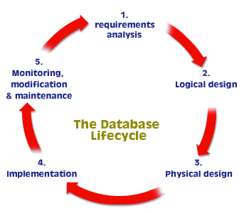

The first three stages are database-design stages, which are briefly described below.

**Requirements analysis:**

Requirements Analysis is the first and most important stage in the Database Life Cycle. It is the most labor-intensive for the database designer. This stage involves assessing the informational needs of an organization so that a database can be designed to meet those needs.

**Logical design**

During the first part of Logical Design, a conceptual model is created based on the needs assessment performed in stage one. A conceptual model is typically an entity-relationship (ER) diagram that shows the tables, fields, and primary keys of the database, and how tables are related (linked) to one another.

The tables sketched in the ER diagram are then normalized. The normalization process resolves any problems associated with the database design, so that data can be accessed quickly and efficiently.

* conceptual model: A description of the structure of a database.
* entity-relationship (ER) diagram: A diagram used during the design phase of database development to illustrate the organization of and relationships between data during database design.
* normalization: The process of applying increasingly stringent rules to a relational database to correct any problems associated with poor design.

**Physical design**

The Physical Design stage has only one purpose: to maximize database efficiency

This means finding ways to speed up the performance of the RDBMS. Manipulating certain database design elements can speed up the two slowest operations in an RDBMS: retrieving data from and writing data to a database.

**Implementation**

During the implementation stage of the DBLC, the tables developed in the ER diagram (and subsequently normalized) are converted into SQL statements and “fed” into the RDBMS to create a database. By this stage in the DBLC, the System Administrator has installed and configured an RDBMS.

System administrator: The person responsible for administering a multi-user computer system; duties range from setting up and configuring system components (e.g., an RDBMS) to performing maintenance procedures (e.g., database backups) on the system.

**Monitoring, modification, and maintenance**

A successfully implemented database must be carefully monitored to ensure that it’s functioning properly and that it’s secure from unauthorized access. The RDBMS usually provides utilities to help monitor database functionality and security. Database modification involves adding and deleting records, importing data from other systems (as needed), and creating additional tables, user views, and other objects and tools.